The Essential Main Ideas of Neural Networks (Part 1) 🧠
The video introduces Neural Networks (NNs) not as a "black box," but as powerful "squiggle fitting machines" built from simple, repeatable components.

I. Core Function and Motivation
- The Goal: Squiggle Fitting: The fundamental purpose of a simple NN is to fit a curved, non-linear function (a "squiggle") to data. [03:02]
  - Limitation of Linear Models: A straight line (like in linear regression) cannot accurately model complex or non-linear data patterns (e.g., predicting effectiveness for low, medium, and high dosages where only medium is effective).
  - NN Solution: An NN can model intricate squiggles that accurately predict complex patterns.
- Architecture: NNs consist of nodes (neurons) and connections between them. [03:39]
  - Input Layer: Takes the raw data (e.g., drug dosage).
  - Hidden Layers: Layers of nodes between the input and output. These layers do the computational heavy lifting. [07:12]
  - Output Layer: Provides the final prediction (e.g., effectiveness: 0 or 1).

II. The Building Blocks: Weights, Biases, and Activation Functions
- Parameters (Weights and Biases): [04:00]
  - Weights: Parameters on the connections that multiply the inputs. They are analogous to the slope in a linear model. [17:13]
  - Biases: Parameters that are added to the weighted sum. They are analogous to the intercept. [17:13]
  - Fitting: These parameters start with unknown values and are estimated by fitting the NN to the data using a method called Backpropagation (to be discussed in Part 2).
- Activation Functions: [05:45]
  - What they are: Bent or curved lines inside the hidden nodes that serve as the non-linear building blocks for the "squiggle."
  - Purpose: They introduce non-linearity to the model. Without them, stacking multiple layers would just result in a single linear function, defeating the purpose of a deep network.
  - Examples:
    - Sigmoid: A classic S-shaped curve (historically common).
    - ReLU (Rectified Linear Unit): A bent line (max(0, x)). Very common in practice.
    - Soft Plus: A smooth curve used in the video's example.

III. How the Squiggle is Built (Forward Propagation)
The NN creates a final complex output curve by slicing, flipping, stretching, and summing the simple activation functions. [08:00]
- Step 1: Calculate the x-axis Coordinate: For each connection from the input to a hidden node, the input value is transformed linearly. [08:29]
  - Formula: x-coordinate = (Input × Weight) + Bias
- Step 2: Apply the Activation Function: The x-coordinate is plugged into the activation function (e.g., Soft Plus) to get the y-axis output value for that hidden node. [09:07]
- Step 3: Transform and Scale the Curve: The output of the activation function (which creates a simple curve) is then scaled by the weight on the connection from that hidden node to the output node. A negative weight can flip the curve. [11:46]
- Step 4: Summation: The transformed curves from all hidden nodes are added together. This summation creates a new, more complex "green squiggle." [15:03]
- Step 5: Final Adjustment (Output Bias): A final bias is subtracted (or added) at the output layer to shift the final green squiggle vertically and fit the data perfectly. [15:13]
The final complex squiggle is the result of adding together simple, transformed activation functions. [17:39]

Interview Perspective & Use Cases 🎤
The key to a successful interview discussion on NNs is moving beyond the structure and focusing on the underlying math and the "why."

Common Interview Questions & How to Answer
Interview Question | Required Answer Focus
"What is the single most important component of a Neural Network?" | Activation Function. Your answer must emphasize that without the activation function (introducing non-linearity), stacking layers of nodes would only ever result in a linear model, making the network useless for complex data.
"Explain the difference between a Weight and a Bias." | Weights determine the slope/steepness of the relationship and control scaling/rotation. Biases determine the y-intercept and control shifting the activation function curve left or right (in the hidden layer) or shifting the final output curve up or down.
"What is a Hidden Layer? How do you decide the number of layers/nodes?" | A Hidden Layer performs feature transformation. Its output is an input to the next layer, not the final result. In a practical interview, state that layer/node count is usually determined through cross-validation and hyperparameter tuning, guided by rules of thumb (e.g., starting with one hidden layer or using an architectural search).
"What is Forward Propagation vs. Backpropagation?" | Forward Propagation is the process shown in the video: calculating the output by moving inputs from the first layer to the last. Backpropagation is the learning process: calculating the error at the output and propagating it backwards through the network to adjust the Weights and Biases to minimize that error.
"Why is ReLU (or Soft Plus) generally preferred over Sigmoid?" | Vanishing Gradient Problem. Sigmoid's derivatives (gradients) are very small near the extremes (0 or 1). During backpropagation, these small gradients get multiplied across layers, causing them to "vanish," which stalls learning in deep networks. ReLU does not suffer from this as severely.
Export to Sheets

Practical Use Cases and Applications
- Computer Vision (CNNs): The foundation of object detection, facial recognition, and image classification.
- Natural Language Processing (RNNs/LSTMs/Transformers): Used in translation (Google Translate), text generation (LLMs), and sentiment analysis.
- Time Series Forecasting: Predicting stock prices, weather, or server load.
- Recommender Systems: Providing highly personalized movie, music, or product suggestions (e.g., Netflix).
- Autonomous Driving: Image segmentation, object tracking, and decision-making for self-driving cars.
Neural networks are the foundational technology behind modern Deep Learning—the practice of using NNs with many hidden layers. Your ability to explain the core concepts (Weights, Biases, Activation Functions, and Backpropagation) clearly and non-mathematically will be critical.
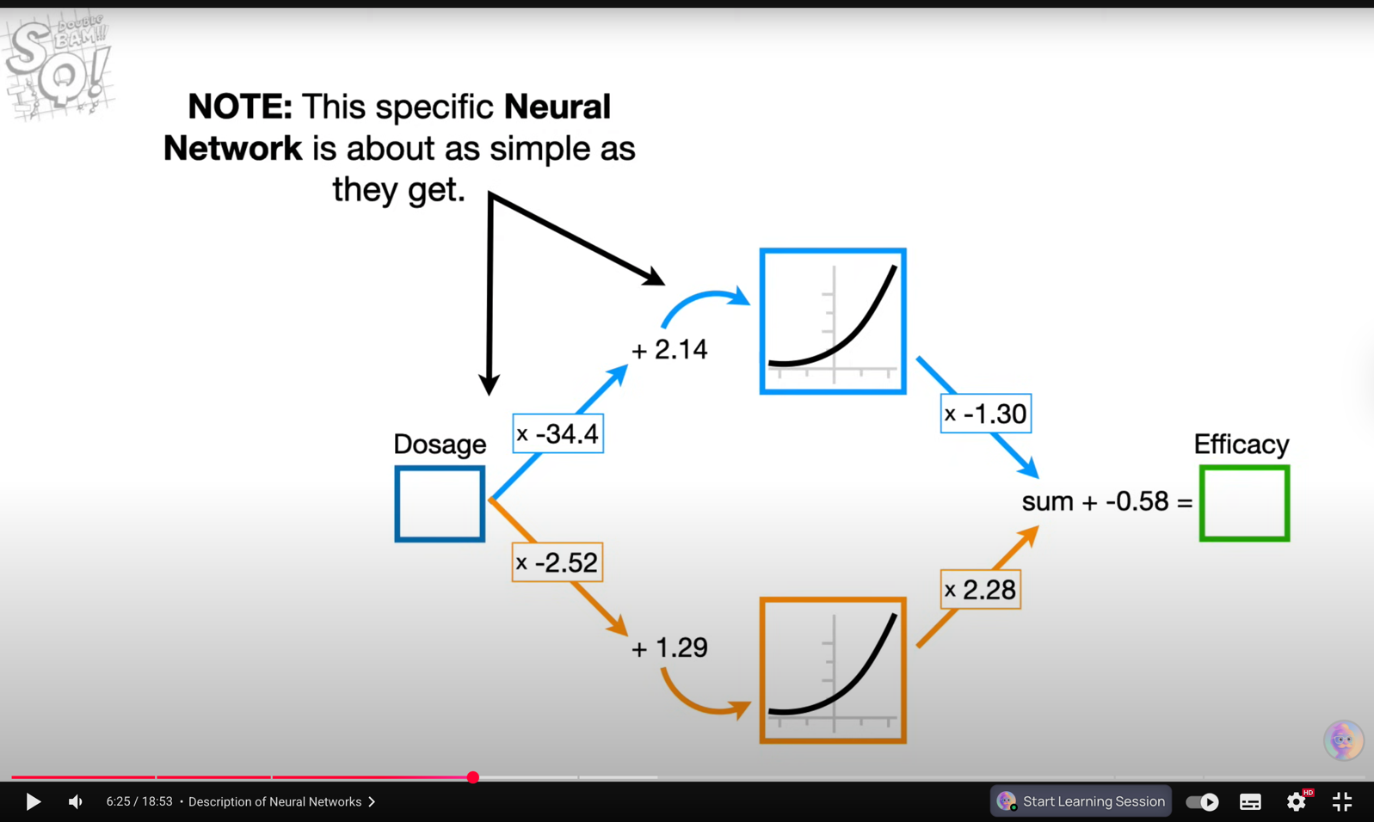

Chain Rule:
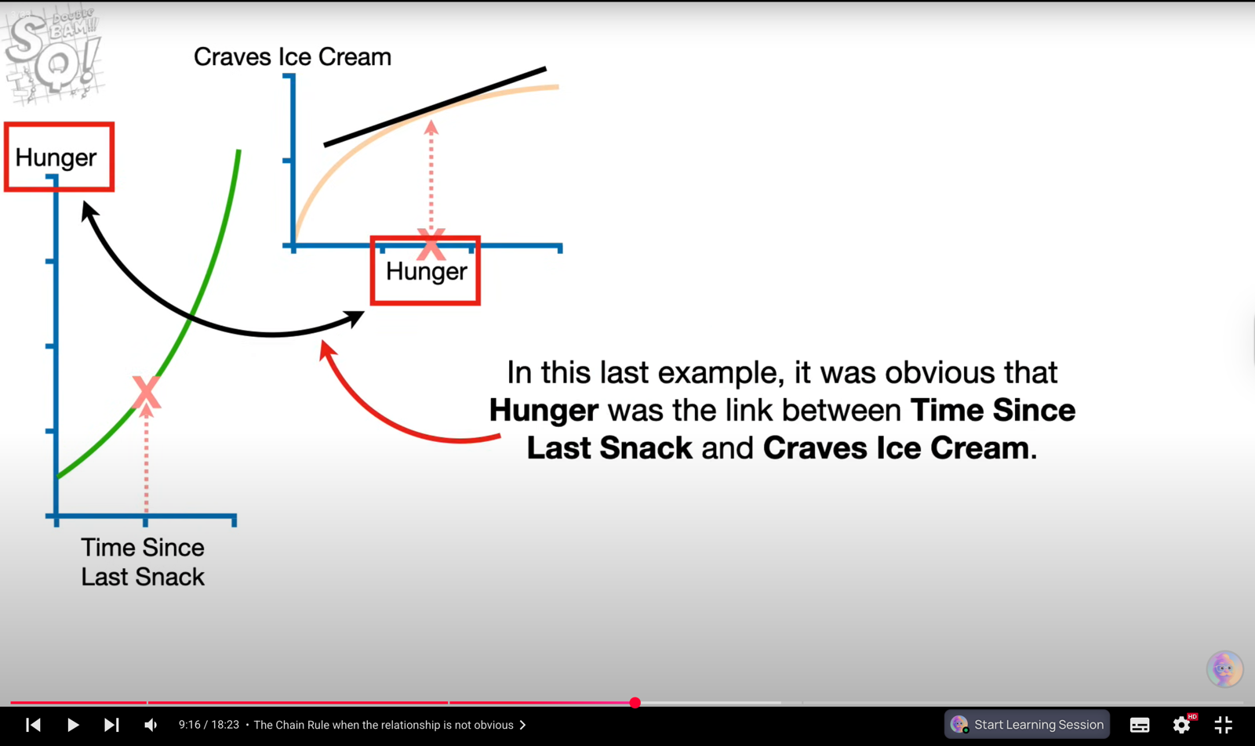

The Chain Rule: The Engine of Learning ⚙️
The Chain Rule is a formula used to compute the derivative of a composite function (a function made up of nested functions). It is essential for efficiently calculating how a change in a variable at the beginning of a process affects a result at the end of the process.

I. Core Concept and Intuition
- Composite Functions: These are functions where one variable depends on another, and that second variable depends on a third (e.g., ).
  - Analogy (The Chain): If Weight affects Height (Function ), and Height affects Shoe Size (Function ), the Chain Rule finds the overall rate of change of Shoe Size with respect to Weight.
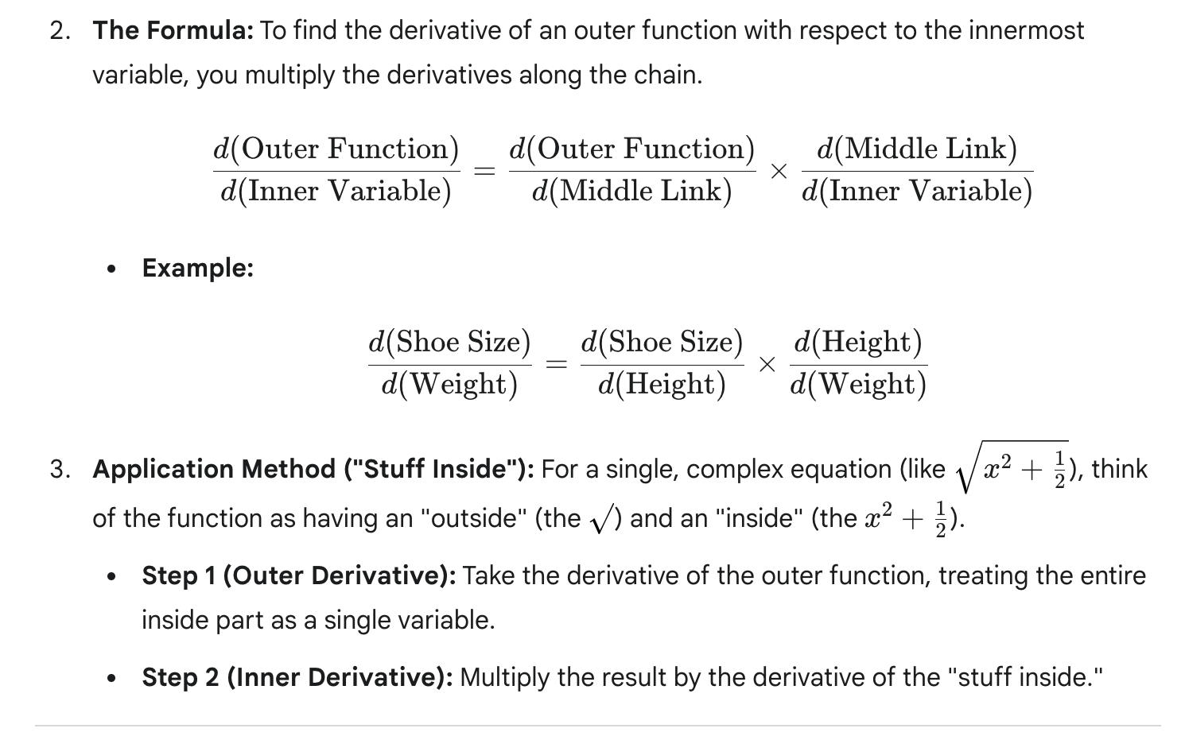

II. Application to Machine Learning (Backpropagation)
The Chain Rule is the mathematical backbone of Backpropagation—the algorithm that allows Neural Networks to learn by minimizing error.
- The Goal: Find the parameter values (weights and biases) that minimize the Loss Function (e.g., Sum of Squared Residuals). This requires calculating the gradient (the derivative of the Loss) with respect to every single parameter.
- The Problem: The Loss is a function of the prediction, which is a function of the output of the final neuron, which is a function of the output of the second-to-last neuron, and so on, all the way back to the initial input weights. This is a very long composite function.
- The Chain Rule Solution: It efficiently calculates the total derivative for an early-layer weight by multiplying all the local derivatives (gradients) along the path from that weight to the final loss:
  - Local Impact of Loss: The first term in the chain measures how much the Loss changes with respect to the immediate previous output (the residual).
  - Local Impact of Parameter: The last term in the chain measures how much the Residual changes with respect to the parameter (e.g., the intercept).
  - By multiplying all these local rates of change together, the network gets the necessary gradient to update that specific parameter using Gradient Descent.

Data Science Interview Prep: Connecting Calculus to Code 👩‍💻
For an interview, you must be able to move beyond the formula and explain the functional significance of the Chain Rule in a deep learning context.
Interview Question | Key Concepts to Emphasize
"What is Backpropagation, and what role does the Chain Rule play?" | Answer: Backpropagation is the process of calculating the gradient of the loss function with respect to every single parameter in the network. The Chain Rule is the fundamental mathematical principle that makes this calculation possible and computationally efficient by breaking the massive derivative into manageable, layer-by-layer multiplications.
"Explain the Vanishing Gradient Problem." | Answer: This is a direct consequence of the Chain Rule. If a network uses activation functions whose derivatives are consistently small (like the Sigmoid function), then when these small derivatives are multiplied across many layers (via the Chain Rule), the resulting gradient for the early-layer weights becomes infinitesimally small (vanishes). This prevents the early layers from learning.
"How do you fix the Vanishing Gradient Problem?" | Answer: We primarily address this by using different activation functions, such as ReLU (Rectified Linear Unit), which has a derivative of either 0 or 1, preventing the cascading multiplication of small values. Other methods include Batch Normalization and using Residual Connections (in ResNets).
"Why can't we just calculate the gradient once and move on?" | Answer: Because the model learns iteratively. Gradient Descent takes a step, which changes the parameter values (weights and biases). Since the parameters change, the entire loss landscape changes, meaning the derivative (gradient) at that new location must be calculated again to determine the next optimal step.

The video "Gradient Descent, Step-by-Step" provides a detailed breakdown of the core optimization algorithm used in all of machine learning and deep learning. Here are detailed, interview-ready notes, eliminating the need for you to watch the video again.

Gradient Descent: The Optimization Engine 📉
Gradient Descent is the foundational algorithm used to find the optimal parameters (weights and biases) of a model that minimize its prediction error.

I. Core Concept and Objective
- Objective: To find the combination of model parameters that results in the minimum possible value for the Loss Function (also known as the Cost Function). [01:53]
- Loss Function: A metric (a formula) that quantifies how much a model's prediction deviates from the actual target values. The graph of the loss function forms a "loss landscape" where the goal is to find the lowest point. [02:45]
  - Example: In linear regression, the loss is often the Sum of Squared Residuals (SSR).
- Core Strategy: Gradient Descent starts with a random initial guess for the parameters and then iteratively takes steps toward the minimum. [05:30]
  - Big Steps Far Away: When the model is far from the minimum, it takes large steps.
  - Baby Steps Close By: As it gets closer, the steps become smaller, allowing for fine-tuning.

II. The Step-by-Step Algorithm
The entire process is a loop that repeats until the model parameters converge (stop changing significantly).
- Start with Random Parameters: Pick a random initial value for each parameter (e.g., set the intercept and slope to 0 or 1). [02:20]
- Calculate the Gradient (The Slope): [07:41]
  - Calculate the derivative of the Loss Function with respect to each parameter you wish to optimize. This collection of derivatives is called the Gradient. [19:12]
  - The gradient indicates two things at the current parameter value:
    - Direction: The sign (positive or negative) tells you which way is "uphill." You must move in the opposite direction (downhill).
    - Magnitude: The value (steepness) tells you how far you are from the minimum.
- Determine the Step Size: [10:48]
  - The step size is calculated by multiplying the gradient by a small, positive number:
- Update the Parameter: [11:09]
  - The new parameter value is calculated by subtracting the step size from the old value. This subtraction is key, as it forces the model to move in the descending direction of the loss curve.
- Stop Condition: The loop continues until one of these conditions is met: [13:48]
  - The Step Size is very close to zero (e.g., less than ), meaning the slope is nearly flat and the minimum has been reached.
  - The Maximum Number of Steps (or epochs) has been reached.

III. Key Components and Variations
Component | Description | Interview Significance
Learning Rate () | A hyperparameter that controls the size of the steps taken. It scales the gradient to ensure controlled movement. [10:51] | Critical. If too large, it will overshoot the minimum and diverge. If too small, convergence will be extremely slow.
Stochastic Gradient Descent (SGD) | A variation that uses a randomly selected subset of the data (mini-batch) at each step, rather than the full dataset, to calculate the gradient. [23:05] | Practicality. Makes training on massive datasets (millions of points) computationally feasible and much faster, though the path to the minimum is bumpier.
Mini-batch | The small, random subset of data used in SGD. A common batch size is 32 or 64. | Efficiency. Reduces the training time while still providing a relatively accurate estimate of the true gradient.
Export to Sheets

IV. Data Science Interview Prep: Gradient Descent in Deep Learning 🧠
You must be able to connect Gradient Descent to Neural Networks by explaining the role of Backpropagation.
Interview Concept | Explanation & Connection to GD
Backpropagation | This is the method used to calculate the gradient in a Neural Network. It works by applying the Chain Rule backward from the output layer to the input layer to determine how each weight contributes to the final loss. Once the gradient is calculated, Gradient Descent uses it to update the weights.
Local Minima | In complex, high-dimensional loss landscapes (like those in Deep Learning), Gradient Descent can get stuck in a "valley" that is not the absolute lowest point (global minimum). [16:00]
Optimizers (Advanced) | In practice, vanilla Gradient Descent is rarely used for deep learning. You should mention advanced optimizers which address its limitations:
Export to Sheets

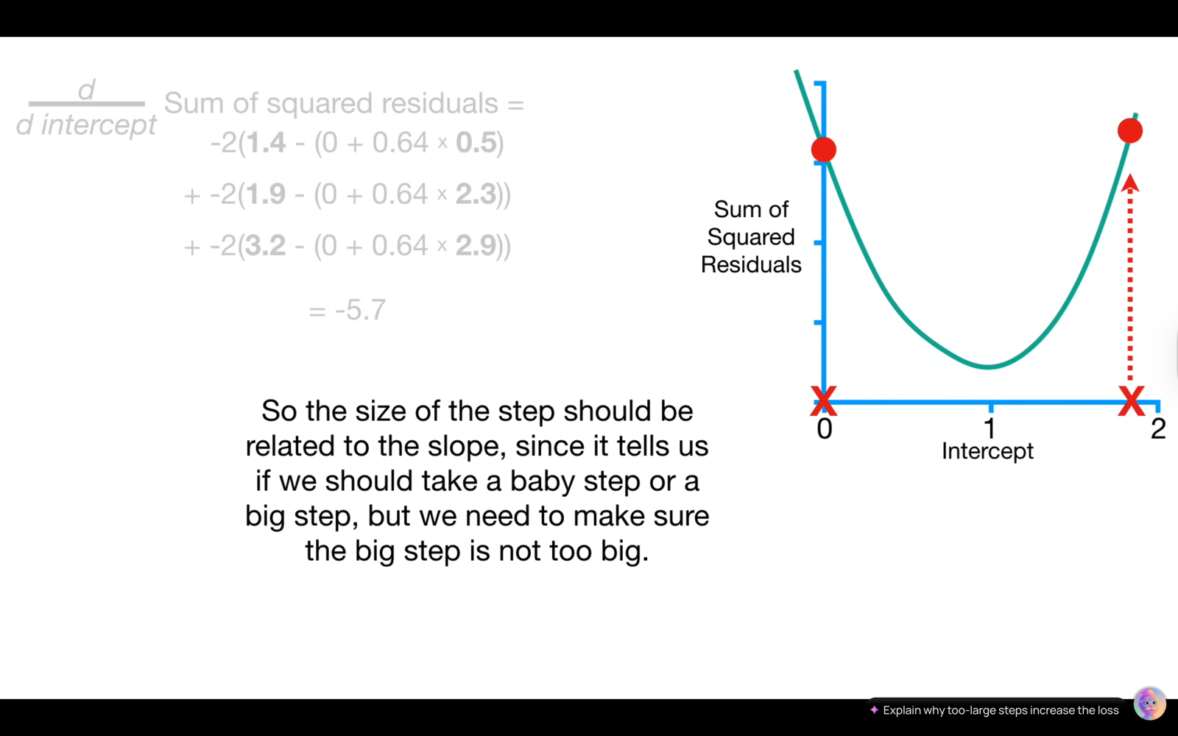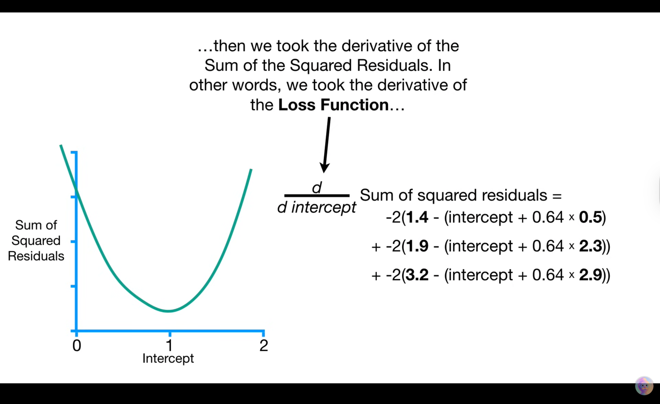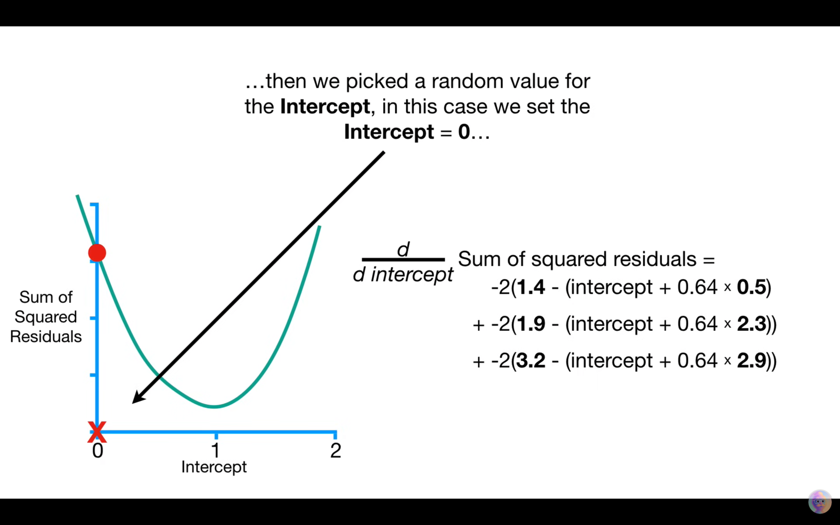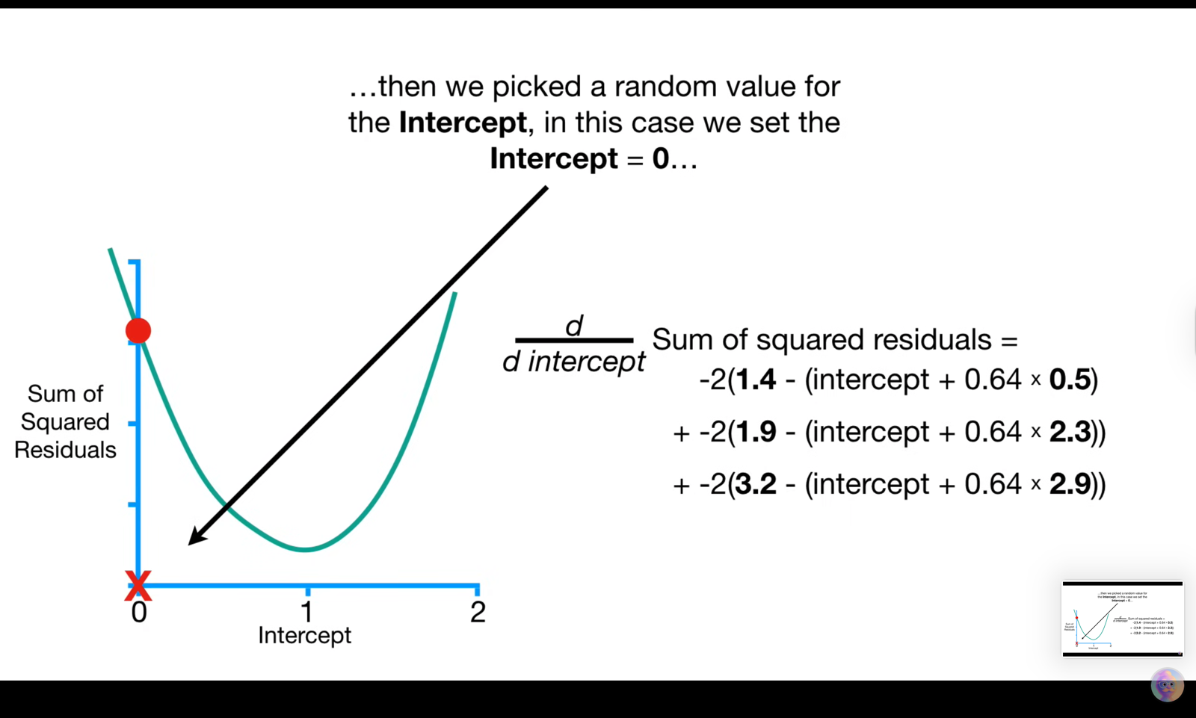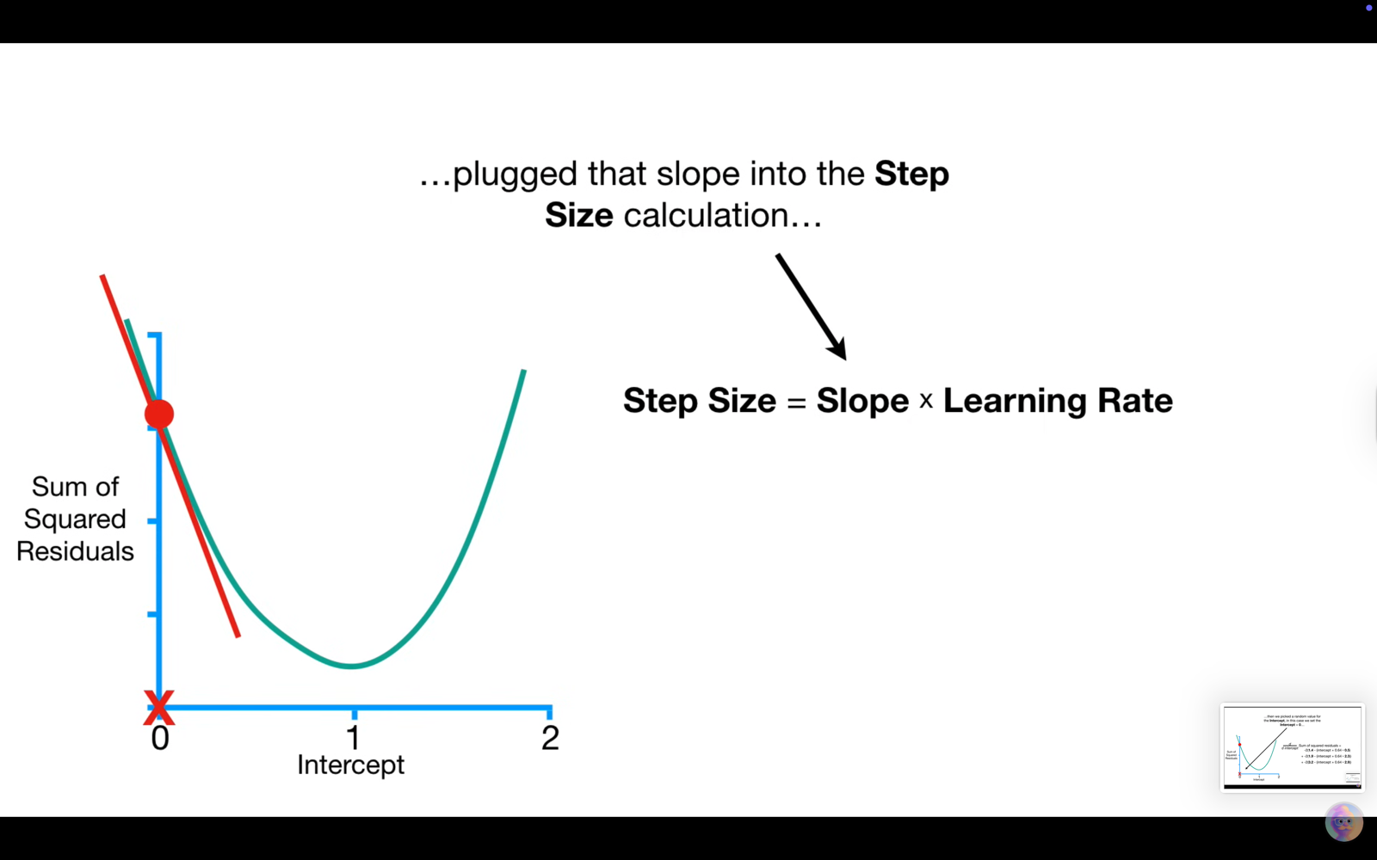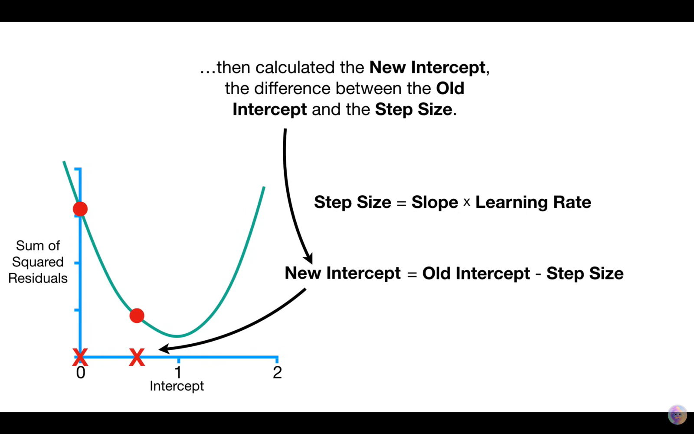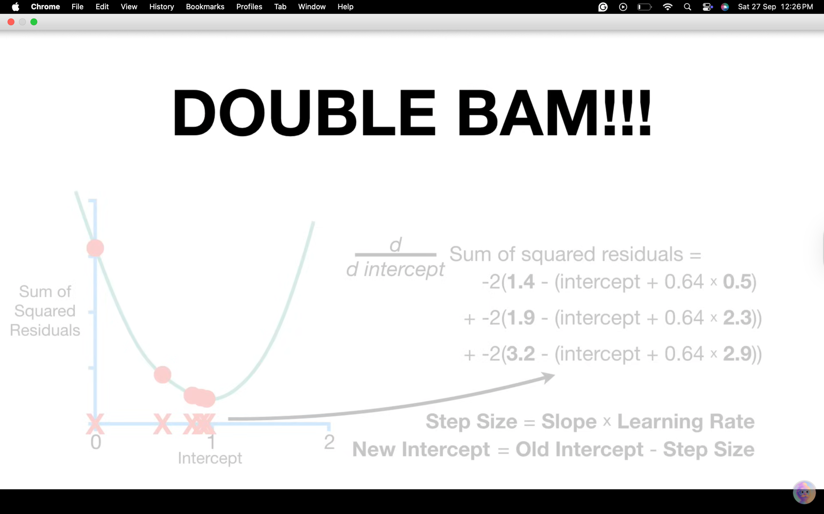

Backpropagation: The Main Ideas 🧠
Backpropagation is the algorithm that efficiently calculates the gradient (the derivatives) of the Loss Function with respect to all the weights and biases in a Neural Network (NN). It is the mechanism by which the network learns and adjusts its parameters.

I. Core Components and Terminology
- Objective: To find the optimal values for all parameters (weights and biases ) that minimize the Loss Function, typically the Sum of Squared Residuals (SSR). [06:02]
- Backpropagation: The conceptual process that starts at the output layer and works backward to estimate the optimal parameters layer by layer. [03:00]
- The Two Main Ideas: [01:54]
  - The Chain Rule: Used to calculate the derivatives (gradient) for a parameter.
  - Gradient Descent: Used to take the gradient and calculate the new, optimized value for that parameter.

II. The Step-by-Step Mechanism (Focusing on a Single Bias)
The video simplifies the process by demonstrating how to optimize just the last bias term (), assuming all other parameters are already optimal. This isolates the core mechanics of backpropagation.
- Calculate the Loss: Start by running the input data through the network and calculating the initial loss (e.g., SSR) based on a random initial value for the parameter being optimized (e.g., ). [06:59]
- Apply the Chain Rule to Find the Gradient: The Loss Function (SSR) is linked to the bias () via the network's Predicted Value. Therefore, the Chain Rule is necessary. [10:38]
  - First Part (): This term measures how much the final loss is affected by a change in the network's output. This is the Error Signal. [11:43]
  - Second Part (): This term measures how much the parameter itself contributes to the output. For a bias term, this derivative is often simply 1, as the bias is just an additive term to the output. [12:31]
- Calculate the Step Size: The calculated gradient (slope) is plugged into the Gradient Descent formula, multiplied by the Learning Rate. [14:25]
- Update the Parameter: The parameter value is updated by moving against the direction of the gradient. [14:43]
- Iteration: This cycle repeats until the parameter converges (the step size approaches zero).

Data Science Interview Prep: Backpropagation 🎤
The key to a successful interview explanation is using the Chain Rule and Gradient Descent concepts to explain why Backpropagation is necessary and how it works.
Interview Concept | Explanation and Practical Significance
Backpropagation vs. Gradient Descent | Backprop is the algorithm for efficiently calculating the derivatives (the gradient). Gradient Descent is the optimization method that uses those derivatives to update the parameters. Backprop answers how much to change a weight; Gradient Descent performs the actual change.
Why is the Chain Rule Key? | It allows the network to calculate the effect of a weight in the first layer on the final loss. The local derivatives are multiplied across all layers, effectively propagating the error signal backward from the output to the input layer.
The Error Signal | The term is the error signal that dictates the learning process. It represents the degree and direction of the error, which is then distributed backward to all preceding layers to update their weights.
Optimizing Hidden Layer Weights | To optimize weights deeper in the network (e.g., in the hidden layer), the Chain Rule extends. The network first needs the error signal calculated at , and then it multiplies that signal by the local derivative of the hidden node output with respect to . This flow of error backwards is the origin of the term "Backpropagation."
Computational Efficiency | Backpropagation is efficient because it re-uses intermediate calculations. Once the derivative for the final layer is calculated, that value is used for all subsequent calculations in the preceding layers, preventing redundant computations.
http://googleusercontent.com/youtube_content/10

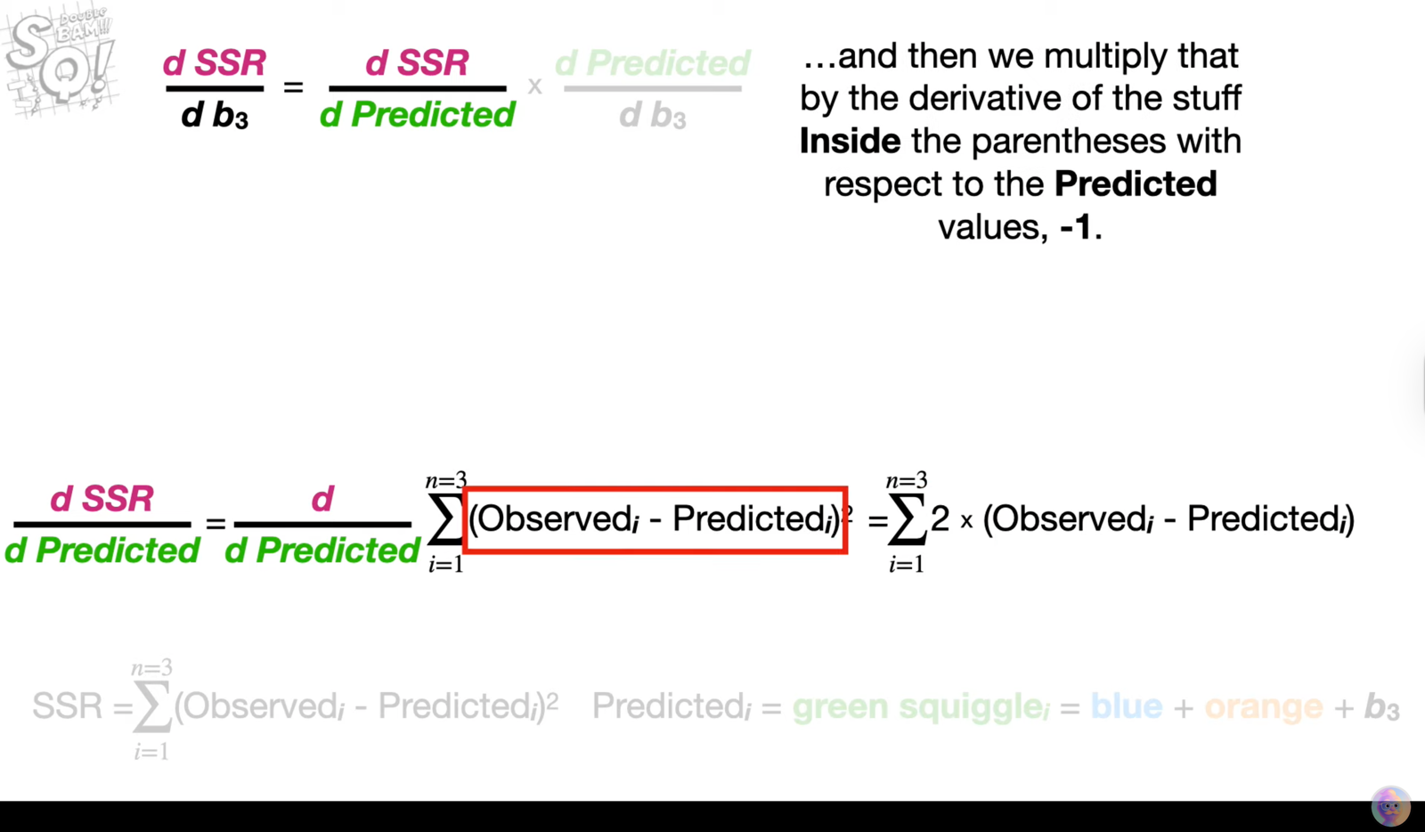

Artificial Neural Networks (ANNs) learn by training on a set of data. For example, to teach an ANN to recognize a cat, we show it thousands of images of cats. The network processes these images and learns to identify the features that define a cat.
Once the network has been trained, we test it by providing new images to see if it can correctly identify cats. The network’s prediction is then compared to the actual label (whether it's a cat or not). If it makes an incorrect prediction, the network adjusts by fine-tuning the weights of the connections between neurons using a process called backpropagation. This involves correcting the weights based on the difference between the predicted and actual result.
This process repeats until the network can accurately recognize a cat in an image with minimal error. Essentially, through constant training and feedback, the network becomes better at identifying patterns and making predictions.

SINGLE LAYER PERCEPTRON

Is it an ANN? Yes — a single-layer perceptron is a very simple type of artificial neural network (no hidden layers).

What it does: takes input → computes linear combination → applies activation → outputs prediction.

Limitation: it can only learn linear decision boundaries. It cannot solve non-linear problems like XOR. That’s the historical reason for introducing hidden layers (MLPs) and nonlinear activations.

Relation to logistic regression: if you replace the step with a sigmoid and train with gradient descent on a logistic loss, you get logistic regression — same linear decision boundary, but probabilistic outputs and different training.

When to use: single-layer perceptrons/logistic regression are good baselines for simple tabular or binary problems; they’re fast, interpretable, and useful when the true boundary is (approximately) linear.

A multi-layer perceptron (MLP) is a feedforward neural network with one or more hidden layers of nonlinear neurons between the input and output. Unlike a single-layer perceptron (a linear classifier), an MLP can learn complex, non-linear functions — it can model interactions, solve problems like XOR, and (with enough width/depth) approximate any continuous function (universal approximation). Training uses forward passes + backpropagation to update weights.

Nonlinear representation: Hidden layers + nonlinear activations let the network learn nonlinear decision boundaries and feature interactions.

Higher capacity: More parameters and layers allow modeling of complex mappings from inputs to outputs.

Feature learning: Hidden layers can automatically learn hierarchical features (low-level → higher-level) instead of relying on manual feature engineering.

Universal approximation: With at least one hidden layer and nonlinearity, an MLP can approximate any continuous function on a compact domain (given sufficient neurons).

Practical flexibility: Works for classification, regression, and as building blocks for deeper architectures (CNNs, RNNs, Transformers).

